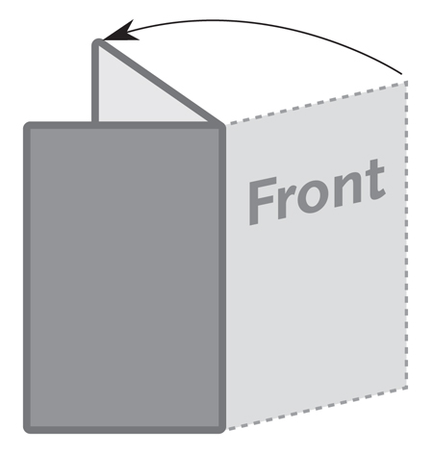

**Half Fold**

**Brochure / Card**

**A5 (148.5mm x 210mm)**

***This is a sample text box.***

***Place the text for your brochure in text boxes like this.***

***The image below is a sample image.***

***Insert the images for your brochure like this.***