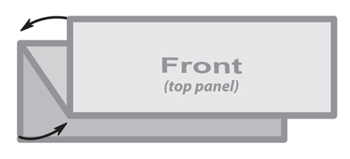

**3 Panel Z Fold Brochure**

**8.5” x 3.667”**

***This is a sample text box.***

***Place the text for your brochure***

***in text boxes like this.***

***The image below is a sample image.***

***Insert the images for your brochure like this.***