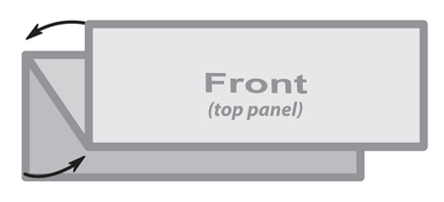

***The image below is a sample image.***

***Insert the images for your brochure like this.***

**3 Panel Concertina**

**210mm x 100mm**

***This is a sample text box.***

***Place the text for your brochure***

***in text boxes like this.***