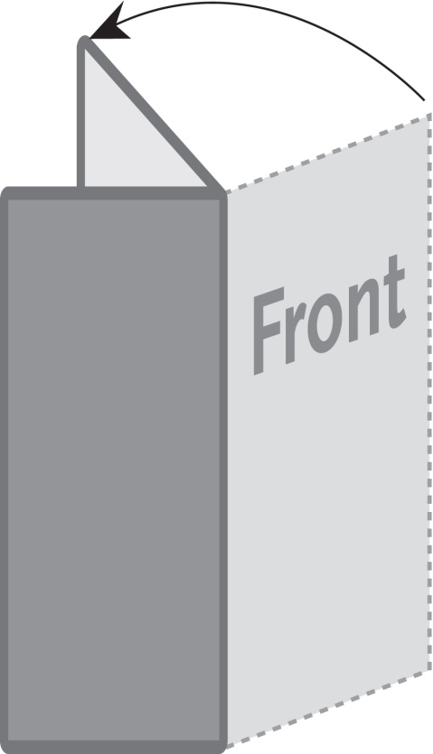

***The image below is a sample image.***

***Insert the images for your brochure like this.***

**2 Panel Tall Brochure / Menu**

**105mm x 297mm**

***This is a sample text box.***

***Place the text for your brochure***

***in text boxes like this.***