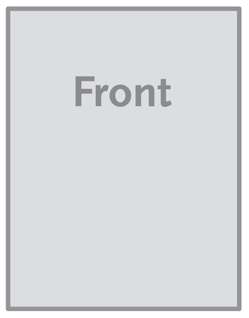

***The image below is a sample image.***

***Insert the images for your brochure like this.***

**Single Sheet / Flyer – A4**

**(210mm x 297mm)**