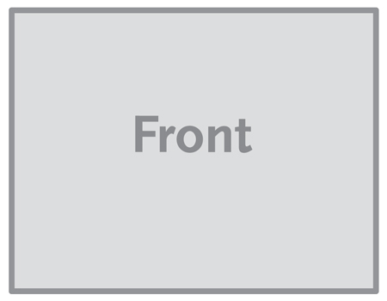

**Single Sheet / Flyer – A4  
(297mm x 210mm)**

***The image below is a sample image.***

***Insert the images for your brochure like this.***